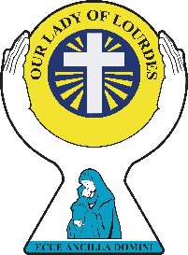
Our Lady of Lourdes Catholic
SCHOOL CONTACT DETAILS
01524 732289
www.olol.lancs.sch.uk

Primary & Nursery School News


Friday 26th June 2026

Our Gospel Value
Mercy

What a very hot and sticky week we have had in school! The children have been amazing even though at times it was very challenging. This week we have been lucky to have two work experience students who have worked across school. A very big thank you for all their help
On Monday, Miss Townson led assembly whilst I attended some training on Writing which will be one of our key priorities next year. It was a hard but great day with lots of things for us to try. Oak & Willow Class had their last session of Rugby from Wigan Warriors and after school our Full Governing Body met to discuss the last term and all the things that school has been involved in. On Wednesday, Miss Townson and I attended some RE moderation with many other Catholic schools and I know that I am biased but, our children’s books were beautiful. A well done to Oak class, it was your books we showed. On Thursday, the children in Elder and Oak class had a very hot and sweaty bowling session – it is always fun!! Maybe when I retire it could be my new sport with Mrs Entwistle. In the evening some of the staff attended the Education Mass at the Cathedral with Bishop Paul. We have ended our week today with Celebration assembly, we had a lot to celebrate!


Next week, we have a few visitors coming to school to see all the work that our children have been doing and we will say a sad goodbye to Miss Sheikh and wish her well as she goes off to her first teaching post. We will begin on Monday by hearing about St Peter & St Paul as it is their feast day. On Tuesday, Mini City Role Play will be visiting Nursery & Reception. I am sure that you will all have a great time. On Thursday, unfortunately Miss Powell will not be here but, the other EYFS staff will still be in class. On Friday we will have a Mufti Day to collect bottles for the Summer Fair which will be held in a few weeks’ time. On Friday we have a visit from the English Hub and we will celebrate our children in Assembly at 3pm.

As always, if anyone has any concerns or worries, please do not hesitate to call, and make an appointment to see us; we are always happy to help and support families as best we can.

Liz Kendall

Our
VIP’s this week are:
LITTLE ACORNS (Nursery)
Neveah Taylor
CHESTNUT CLASS
Ryatt Woodcock
ELDER CLASS
Alek Sieradski
WILLOW CLASS
Gennaro Ceraldi-Palmer
OAK CLASS
Eona Lijo
WELFARE AWARDS
Renaya  Thomas | Alexander  Kowalik


SCHOOL LUNCHES
Next week is Week 2

NEWS FROM THE CLASSROOM
LITTLE ACORNS & CHESTNUT CLASS
In Little Acorns we have explored the universe in our space station.
ELDER CLASS
In Elder Class this week, we have learnt about how to make things balance.
WILLOW CLASS
In Willow Class this week, we have learnt about the Jewish Festival of Passover and how it is celebrated today.
OAK CLASS
In Oak Class this week, we have started the ball rolling with our end of year performance.

PRAYER & LITURGY

On the Solemnity of Saints Peter and Paul, we remember the amazing mystery of the Church! Children will discover that the Church (built on Peter's faith and preached by Paul) helps us to grow in faith and confidence to live out our Christian Mission. They are invited into the mystery of the Church as they continue to build a close friendship with Jesus.
Attendance Update
We are trying really hard to improve attendance in school so that we reach the national targets. The children’s target is 95%.
Let’s all continue to work hard to improve our attendance this week’s attendance has been very low.
Just to let you know that there are some absences with N codes on our registers that we will be chasing up this week – please return letters as soon as possible.
This week
Chestnut Class | Elder  Class | Willow  Class | Oak  Class
86.92% | 86.67% | 90.91% | 90.38%
Well done to WILLOW CLASS

CARNFORTH SINGS

Last year we did Carnforth Sings with Carnforth Community School. This year, the Music Service are trying to get more children involved and so our KS2 children will be joining other children in the local community to rehearse and then put on a performance on 7th July at 2pm in the Methodist Hall. Everyone is welcome to the performance and more details will follow.

SCHOOL SUMMER FAIR

This will be held on Friday 10th July at 3.30pm until 5pm. If you are interested in running a stall or giving us a hand please see Miss Powell. Last year we raised £700 to buy equipment throughout school.

SCHOOL REPORTS
We will be trying a new format and system for sending out our reports this year. Please can you make sure that we have your most recent email address so, that all reports can be emailed out after the Summer Fair.


Autumn Diary Dates
We have included as many dates as we are aware of at this time. We will keep updating this, the school website and will send texts as reminders.

Monday  29th June | 9am Assembly
Tuesday  30th June | Mini Role Play Visit (EYFS)
Wednesday  1st July | 9am MCMAT School Improvement Lead (Laura Byrne) to visit school
Thursday  2nd July | 9.30am Crown Green Bowling (Elder & Willow Class)
Friday  3rd July | MUFTI DAY (Bottles)  English Hub Visit
Monday  6th July | WORK EXPERIENCE STUDENTS BEGIN
Tuesday  7th July | QES Induction Day  Carnforth Sings (2pm Performance at Carnforth Methodist Hall)
Thursday  9th July | 9.30am Crown Green Bowling (Elder & Willow Class)
Friday  10th July | MUFTI DAY (Chocolate)  3.30pm School Summer Fair
Tuesday  14th July | 2pm & 6pm End of Year Production (Oak Class)
Wednesday  15th July | 4.45pm Year 6 Bowling Party
Friday  17th July | 1.30pm School Closes for Summer Break

WEATHER
Our weather changes all the time and is very unpredictable!
Please can you make sure that
your child has a coat if it is raining
and a sunhat and suncream
when the
weather is hot!
Thank you.

INVOICES
Please try to make sure that all invoices are paid before the end of the school year. Thank you

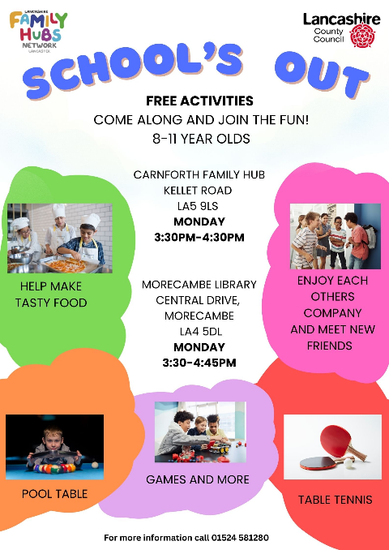
COMMUNITY NEWS




