OUR LADY OF LOURDES CATHOLIC PRIMARY SCHOOL


9
School Curriculum Policy for
ENGLISH (Writing)
(2020/21)
Curriculum Leader: Mrs Liz Kendall

Our School Vision:

“We want our school to be a safe, secure and exciting place to learn and grow in Christ. A place where children, staff, families and governors work closely together to answer Christ’s call.”

Our Catholic School community works with a Christian purpose:
- To promote an enthusiasm for enjoyment of learning
- To provide a broad and well balanced curriculum
- To challenge children to reach their full potential
- To learn about God and his creation
- To answer Christ’s call through our love for each other
- To foster in children independence and a sense of responsibility

“For you are precious in my eyes”
(Isaiah 43)
Contents of this Policy

- Introduction (Vision)

- Curriculum Aims (Our Intention)

- Roles & responsibilities

- Curriculum Planning & Organisation (Implementation)

- Resources

- Assessment (Impact)

- Inclusion (Special Educational Needs & Vulnerable children)

- Monitoring arrangements

- Links with other policies

CURRICULUM AIMS – OUR INTENTION:

Through English at Our Lady of Lourdes we aim for all children to learn to:

- Be happy, healthy and curious learners who write confidently and fluently and seek to acquire knowledge independently.
- To enable pupils to know more, remember more and understand more and use their writing skills as a means of demonstrating this.
- To promote a positive and enthusiastic attitude towards writing.
- To create an interest in words and their meanings in order to broaden vocabulary.
- To create confident, independent writers and spellers.
- To provide the chance for every child to become a writer.
- To create writers who can re-read, edit and improve their own writing.
- To create writers with a legible, joined and fluent handwriting style.
- To prepare pupils for the next stages of their education.
- To provide regular opportunities for pupils to write for a range of purposes and audiences.
- To develop a broad range of writing skills, that can be applied to a wide range of text types and genres across the whole curriculum.

Context for teaching Writing

Writing is taught and learnt in specific, meaningful, and effective contexts. These include:
- Shared and guided reading.
- Complementary grammar and punctuation activities.
- Modelled and shared writing.
- Independent writing both short and long tasks.
- Sharing and reflecting on their writing.
- Cross-curricular writing tasks.

To support children in the acquisition of writing skills we will:

- Provide frequent opportunities to write.
- Provide regular demonstrations of the writing process.
- Provide opportunities to reflect on the writing process.
- Give children time to refine their writing through editing and revising.
- Provide children with opportunities to share their writing.
- Surround children with a print-rich environment, that they have helped to create.
- Reward and celebrate children’s efforts and achievements in writing.
- Teach ICT skills, that support effective and efficient electronic communication.

Within this writing environment, the close relationship between writing and reading needs to be exploited.
We will provide a wide variety of texts which cater for children’s diverse interests and needs, and act as a stimulus to their own writing.

ROLES & RESPONSIBILITES:

THE  GOVERNING BODY | The governing board will monitor the effectiveness of this policy and hold the headteacher to account for its implementation.  The governing board will also ensure that:  - A robust framework is in place for setting curriculum priorities and aspirational targets  - Enough teaching time is provided for pupils to cover the National Curriculum and other statutory requirements  - Proper provision is made for pupils with different abilities and needs, including children with special educational needs (SEN)
THE  HEADTEACHER | The headteacher is responsible for ensuring that this policy is adhered to, and that:  - All required elements of the curriculum, and those subjects which the school chooses to offer, have aims and objectives, which reflect the aims of the school and indicate how the needs of individual pupils will be met  - The amount of time provided for teaching the required elements of the curriculum is adequate and is reviewed by the governing body  - The school’s procedures for assessment meet all legal requirements  - The governing board is fully involved in the decision-making processes, that relate to the breadth and balance of the curriculum
CURRICULUM SUBJECT LEADER | The curriculum leader is responsible for:  - Monitoring and evaluating English.  - The quality of the learning environment.  - Purchasing and organising resources.  - Keeping up to date with recent English developments through their own CPD and that of others.  - Monitoring and assessment of English across the whole school, supporting Pupil Progress meetings.  - Analysing data and creating action plans.  - Overseeing the continuity of the subject and the progression of teaching and learning within annual and medium-term plans.  - Monitoring the quality of teaching and the standard of work produced.  - Collecting evidence from year to year.  - Offering support to colleagues and sharing their expertise and experience.  - Supporting staff in catering for the needs of all the children in their class, ensuring all children access the curriculum at an appropriate level.  - Ensuring proper provision is in place for pupils with different abilities and needs, including children with SEN.  - Reporting to the governing board and ensuring it is advised on any changes to the English curriculum and making them aware of what is happening in school.
CLASS  TEACHERS | Other staff will ensure that the school curriculum is implemented in accordance with this policy. They will:  - Ensure they are aware of the previous knowledge of the children and build on this within lessons.  - Ensure children are given concrete experiences, planning trips, inviting visitors in to school or loaning artefacts.  - Ensure all of our intentions are being taught.

CURRICULUM PLANNING & ORGANISATION (IMPLEMENTATION)

Writing in Early Years Foundation Stage
In the Early Years, children are encouraged to attempt their own emergent writing and their efforts are valued and praised. As their phonic knowledge increases, this will be reflected in their writing. At the same time, their knowledge of key words is supported through reading and writing activities, including shared reading and writing. A wide variety of opportunities are provided for children to engage in writing activities.
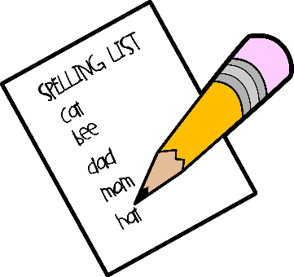
Amongst these are:
- Shared writing
- Role-play (e.g. an office or restaurant)
- Labels
- Recipes
- Lists
- Making books
- Writing letters
- Menus

Through engaging in these activities, children become aware that writing is used for a range of purposes. They distinguish it from drawing and learn the left to right convention of writing in English. A variety of resources are used to encourage the development of the fine motor control which is essential for good handwriting. These include playdough, cutting, threading and tracing.

Writing in Key Stage 1

Shared & Guided Writing
Through shared writing the teacher demonstrates specific writing skills, sometimes acting as scribe. The basics of how to form a letter, spell a word, leave a space or put in a full stop are demonstrated, followed later by the more sophisticated strategies of modelling the planning, drafting or proof-reading of writing.
The teacher may also demonstrate writing in a genre. Shared writing will teach children how to:
- Generate imaginative and informative ideas through discussion and questioning, and record these ideas in notes/ plans/ drafts
- Structure ideas in writing through the use of appropriate language, sentence structure, punctuation, sequencing and lay-out
- Develop specific word level skills of spelling, handwriting and punctuation
- Refine writing to make it clearer and better suited to its audience and purpose
- Develop technical terms and vocabulary for understanding and discussing writing
- Publish and present written texts for others to read and use

Independent Writing (Short Writing Tasks & Big Write)
Children will be given frequent opportunities to write independently, so that the skills demonstrated during shared writing will be transferred into their own writing. Since accurate, fluent and independent writing is dependent on a secure grasp of phonics, a high priority is placed throughout EYFS and KS1 on daily systematic phonics teaching (based on the ‘Jolly Phonics’ programme). This gives children the strong and essential foundation upon which all their future development as writers will be built. Motor skills continue to be developed through targeted small groups as necessary.

Writing in Key Stage 2

Shared & Guided Writing
Through shared writing the teacher will model the writing process with the children. This may include:

- Demonstrating planning strategies (e.g. concept maps, writing frames)
- Using a familiar text as a starting point for writing
- Teaching the structural characteristics of a particular text type
- Teaching the purpose and use of punctuation
- Playing with language and exploring different language choices
- Modelling higher level sentence constructions (e.g. conjunctions, complex sentences)
- Drafting
- Demonstrating revision strategies (e.g. checking for meaning, reordering to improve structure, rewriting to improve clarity or to enrich language)
- Demonstrating editing strategies (e.g. checking punctuation and spelling, using writing targets).

Independent Writing (Short Writing Tasks & Big Write)
During independent writing, the children compose without direct teacher support. As children move through KS2, they will be expected to write regularly and at increasingly greater length, developing crucial writing stamina alongside other skills. Independent writing, both within English lessons and across the curriculum will involve:
- Using imagination and expressing ideas
- Applying skills learned in shared writing and guided writing
- Focusing on individual writing targets
- Revising work, in the light of feedback from teachers or peers
- Commenting constructively on other children’s writing
- Editing and proof-reading to improve transcriptional features
- Preparing work for presentation

Grammar and Punctuation
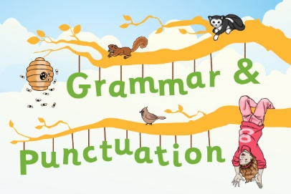
Grammar and punctuation teaching is most effective when it is short, sharp and frequent.
Word and sentence games encourage children to enjoy playing with language and to experiment with different constructions, that they may then apply in their independent writing. For children to make progress as writers, they need to develop 4 key elements of their writing that are transferable across all writing genres.
These are:
- Vocabulary (making ambitious language choices, carefully selecting adjectives, adverbs and verbs for specific purposes)
- Conjunctions (using a range of conjunctions to form complex sentences)
- Openers (starting sentences in different ways, including using adverbs, time phrases and ‘ed’, ‘ing’ and simile clauses)
- Punctuation (steadily broadening the range of punctuation used, exemplified in the ‘Punctuation Pyramid.’) Accuracy in basic punctuation (capital letters and full stops) is given a high priority throughout the school. Explicit teaching may be needed, even for older children, on what a sentence is and how to punctuate it accurately.

Handwriting:
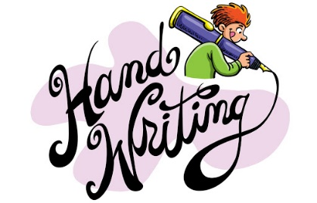
Aims:
- To develop a sense of pride, pleasure and enjoyment in their handwriting
- To adopt fluent, legible and joined handwriting
- To adapt lettering styles for different purposes

Children in KS1 and the Early Years use pencil.
In Year 3, children are progressively introduced to handwriting pens when ready.
By the end of Year 4, all children should be writing in pen.
Cross-curricular opportunities are used to provide real purposes for using handwriting skills. The motor skills, necessary for handwriting, will also be developed in Art & Design, Design & Technology and Physical Education.

Children will need guidance as to the best way to orientate the paper on which they will be writing, particularly if they are left-handed. Left-handed children should sit on the left or beside another left-handed child when paired. In addition, they may benefit from the use of a pencil grip. Particular attention is paid to handwriting in the final draft of a piece of written work, especially in KS2. All pupils should be using joined writing throughout KS2.

PARENTAL INVOLVEMENT:

At Our Lady of Lourdes, we strive to develop and encourage a strong partnership between home and school. It is our policy to encourage our parents to participate in their children’s writing development through homework.

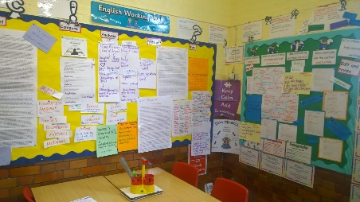
DISPLAY:

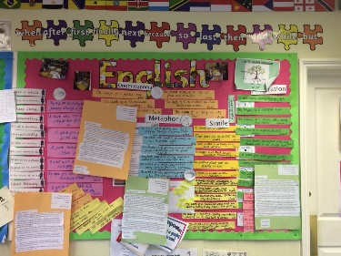
Classrooms and all school areas should provide a print rich environment to promote the importance of writing. An English working wall should form a part of that environment.

RESOURCES:

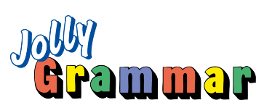
A range of different resources are used to help support children’s writing.
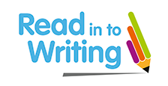
- Jolly Phonics (Jolly Learning)
- Jolly Grammar & Spelling (Jolly Learning)
- No Nonsense Spelling (Babcock)
- GPS Mats (Twinkl)

ASSESSMENT:

A whole school approach to assessment and record keeping is used (iTrack Primary). Teaching staff also maintain their own individual class records of achievement in writing. Assessment and feedback to pupils is usually carried out by observation and oral feedback during lessons.
Summative assessment data is reported termly and analysed by the English Curriculum Subject Leader to provide support to those in need.

INCLUSION:

Individual class teachers will devise intervention programmes based on the needs of individual pupils. Children may be assigned 1:1 time or work in small groups based on individual needs or Assess, Plan, Do, Review Plan targets, if the pupil is on the SEND register. Consultation with the school SENCO is essential to ensure children are placed on programmes appropriate to their needs.
Teachers set high expectations for all pupils. They will use appropriate assessment to set ambitious targets and plan challenging work for all groups, including:
- More-able pupils
- Pupils with low prior attainment
- Pupils from disadvantaged backgrounds
- Pupils with SEN
- Pupils with English as an additional language (EAL)
Teachers will plan lessons so that pupils with SEN and/or disabilities can study every National Curriculum subject, wherever possible, and ensure that there are no barriers to every pupil achieving.
Teachers will also take account of the needs of pupils whose first language is not English. Lessons will be planned so that teaching opportunities help pupils to develop their English, and to support pupils to take part in all subjects.
Further information can be found in our statement of equality information and objectives, and in our SEN policy and information report.

MONITORING & TRAINING:

Senior Leaders and Curriculum leaders monitor the way their subject is taught throughout the school by:
- Learning walks
- Book scrutiny
- Child discussions
- Teacher discussions
- CPD for the Curriculum leader as required (Ofsted - Sandylands Hub)
- Staff Meeting Focus on English and the curriculum
- INSET training on using resources and making English engaging

LINKS WITH OTHER POLICIES:

This policy links to the following policies and procedures:

- EYFS policy
- Reading policy
- Handwriting policy
- SEN policy and information report
- Subject Guidance for Reading
- Subject Guidance for Writing

Policy  Date: | September 2020
Policy Review  Date: | September 2021
Signed &  Dated: | Chair of Governors
Signed &  Dated: | Headteacher Curriculum Leader

