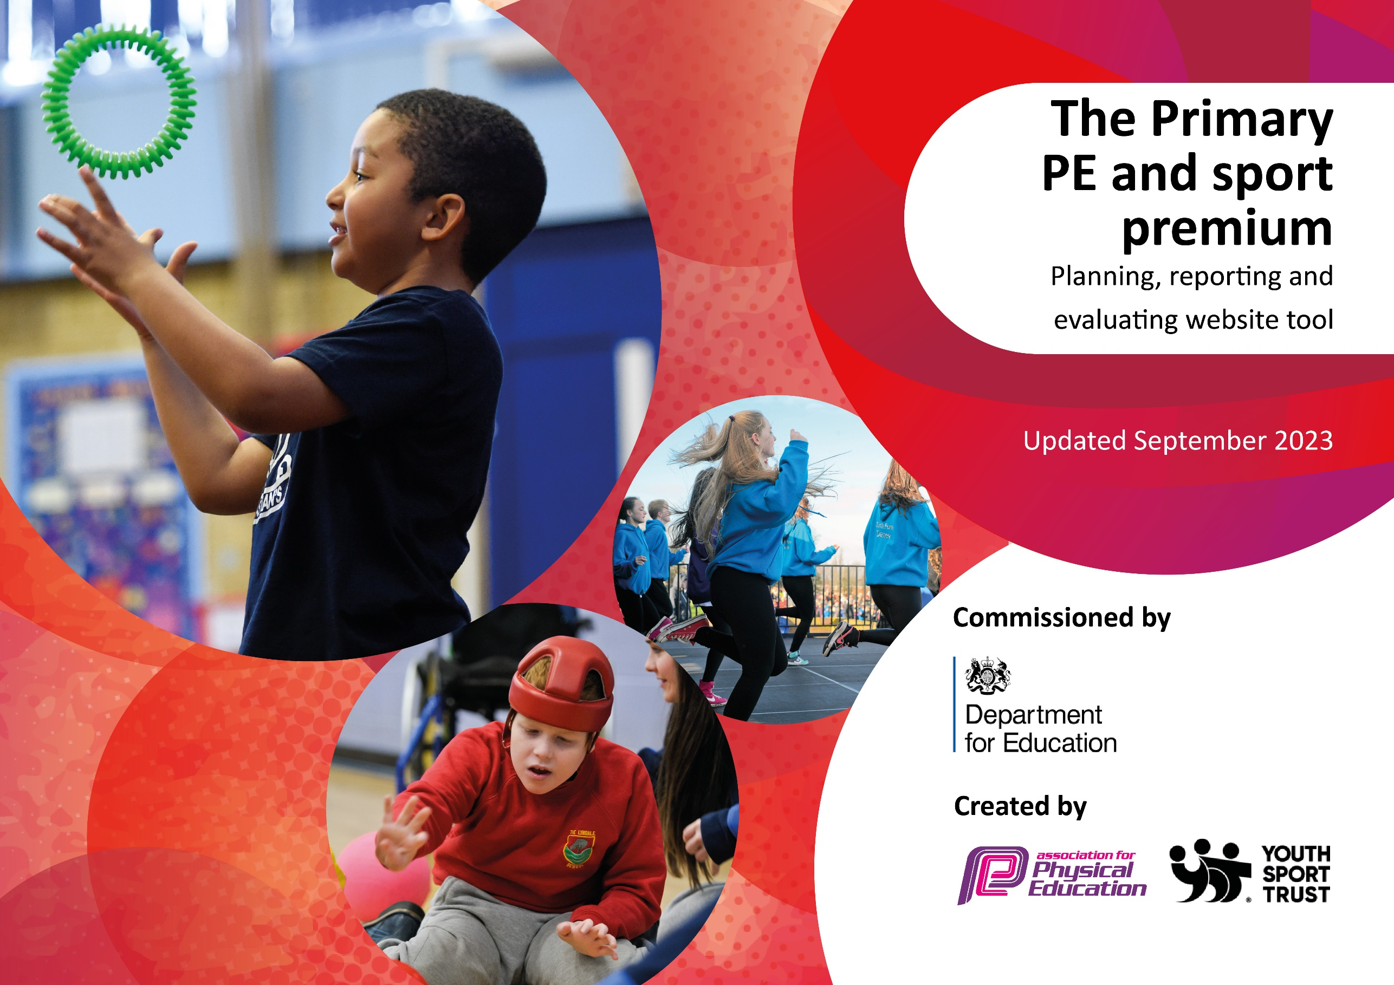

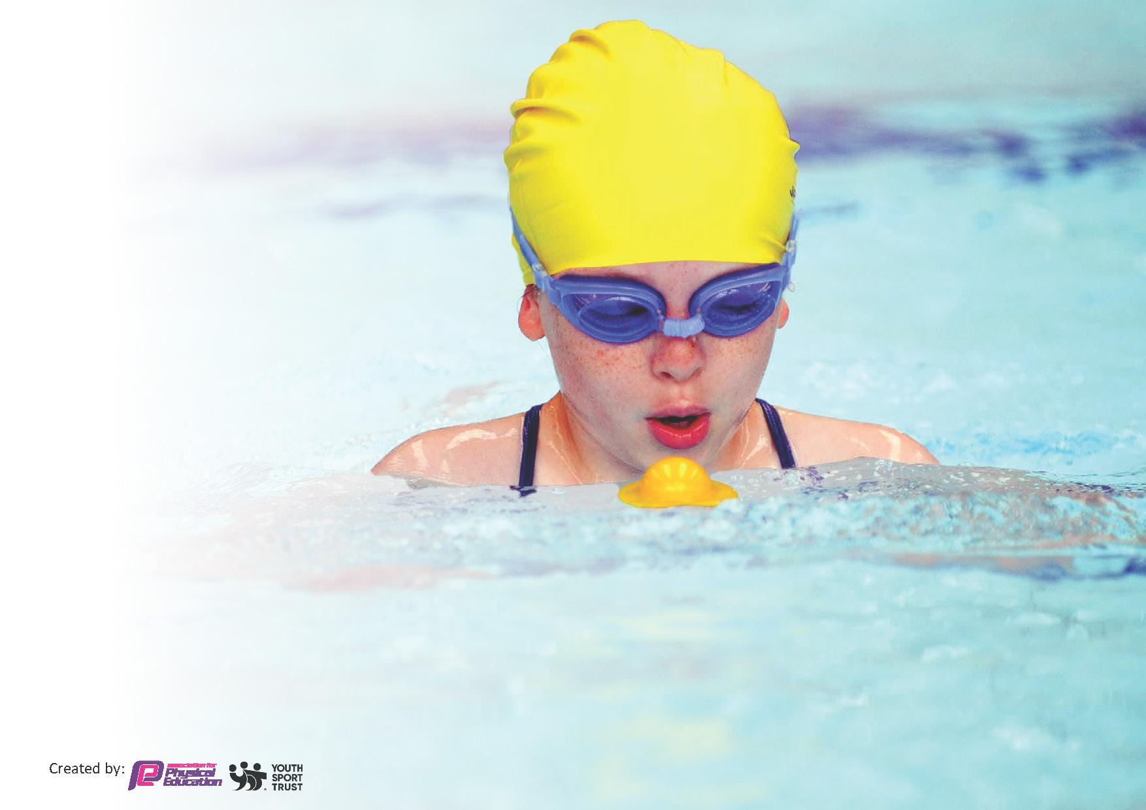
This template can be used for multiple purposes:
by:
- It enables schools to effectively plan their use of the Primary PE and sport premium
- It helps schools to meet the requirements (as set out in guidance) to publish information on their Primary PE and sport premium
- It will be an effective document to support Ofsted inspections enabling schools to evidence progress in Physical Education (PE) and evidence swimming attainment, which forms part of the PE National Curriculum. We would recommend schools consider
the Intent, Implementation and Impact of any spend, as examined within the Education Inspection Framework.

It is important that your grant is used effectively and based on school need.

Schools must use the funding to make additional and sustainable
improvements to the quality of the PE, School Sport and Physical Activity (PESSPA)
they offer. This means that you should use the Primary PE and sport premium to:

- Build capacity and capability within the school to ensure that improvements made now will benefit pupils joining the school in future years
- Develop or add to the PESSPA activities that your school already offers.

The Primary PE and sport premium should not be used to fund capital spend projects; the school’s core budget should fund these. Further detail on capital expenditure can be found in the updated Primary PE and sport premium guidance.

The Primary PE and sport premium guidance, outlines 5 key priorities that funding should be used towards. It is not

necessary that spending has to meet all the key priorities, you should select the priorities that you aim to use any funding towards.

Although completing this template is not a requirement for schools, schools are required to publish details of how they spend this funding. Schools must also outline what the impact this funding has had on pupils’ PE and sport participation and attainment and how any spending will be sustainable in the future. All funding must be spent by 31st July 2024.

The Department for Education has worked closely with the Association for Physical Education (afPE) and the Youth Sport Trust (YST) to develop this template and encourages schools to use it. This template is an effective way of meeting the reporting requirements of the Primary PE and sport premium.
Review of last year’s spend and key achievements (2024/2025)

We recommend you start by reflecting on the impact of current provision and reviewing your previous spend.

Activity/Action | Impact | Comments
- To improve the teaching of and provision for children across the school in all areas.  We invested lots of our funding into early years. It is widely acknowledged that in order for children to succeed throughout school, the foundations must be in place. If children can master gross motor skills throughout nursery and reception, they are more likely to be able to sit at a table, write legibly and access much of the curriculum offered in later years.  - Enable children to grow leadership within the school, ensuring pupil voices and opinions are heard in improving both our school and the local community.  Our legacy of a sports committee was continued and children were trained in young leadership and also, this year, football leadership to ensure they are developing their leadership roles throughout school. The children have also chosen some equipment for the playground which will be replenished again this year.  - Support the children’s emotional wellbeing.  Children from Key Stage One took part in Healthy Heads programme which encourages them to look after both physical and mental health. This will be continued this year.  - To ensure that we offer a range of opportunities to nurture, develop and stretch all children’s talents and interests to broaden their development.  Children took part in a large range of competitions and non-competitive sports with all children in Key Stage 2 attending the Salt Ayre Sports Festival in the summer. We have also offered children opportunities to explore the outdoors and a range of different sporting activites through trips such as Williamson’s Park | - The children in early years have had more physical gross motor activity outside in their own area.  - The children within Year 1 (that used some of the equipment towards the end of last year) generally have good fine and gross motor skills and are able to sit to complete work.  - The children in Y5/6 are confident leading activities for other children on the playground and have accepted the responsibility of being a good role model for sport.  - Lunch times are more active and children are able to play sports that are suited to them due to voices of the children being heard.  - Children in all age groups have a good understanding of what Is needed to look after their own mental wellbeing.  - Children from Y3-6 have represented school in football, handball, athletics, archery, dodgeball giving children an opportunity to experience a range of sports to encourage a healthier lifestyle.  - Some children who were unwilling to participate in sport represented school and have now put their names forward for other events.

Key priorities and Planning
This planning template will allow schools to accurately plan their spending.

Action – what are you planning to do | Who does this action impact? | Key indicator to meet | Impacts and how sustainability will be achieved? | Cost linked to the action
Employ current TAs to lead after school sports clubs.  Plan activities for each class based around outdoor and adventurous pursuits that encourage the children to be outdoors and taking part in new activities  Coaches to support staff in developing their knowledge of coaching and teaching curriculum P.E.  Buy in to Sports networks – LHSSN and CSSN.  Buy extra swimming sessions for those children who are yet to swim 25 metres  Buy equipment for sensory circuits.  Buy playground equipment to encourage children to be active at playtimes.  Develop Sports Committee further | TA – MN  T – KD  Teaching staff – KD, NP, HT, EK  KD plus TA  KD  KD  KD HT NP EK(SENDCO)  KD  KD | 1 and 4  4  3  3, 4, 5  1, 2  2  1  1,2,4,5 | This will ensure that more sports clubs are on offer and available to all children at school to increase the activity levels of the children in our school.  This will encourage children to find other activities that might interest them. It will also widen their experiences.  TAs will be confident in leading PE sessions as well as leading clubs outside of school.  CPD opportunities for all staff as required including for subject leader to ensure up to date knowledge.  Children will all be capable of swimming 25 metres and will achieve water safety.  To ensure that all children are given the physical adaptations within school to reach their potential.  Children will be more active at playtimes.  Children will take part in varied activities at lunch times. Older children will develop their leadership skills. | £3000  Subsidised - £1500  £3500  £4350  £1000  £2000  £1000  £0

Key achievements 2024-2025
This template will be completed at the end of the academic year and will showcase the key achievements schools have made with their Primary PE and sport premium spending.

Activity/Action | Impact | Comments

Swimming Data
Meeting National Curriculum requirements for swimming and water safety.
Priority should always be given to ensuring that pupils can perform safe self-rescue even if they do not fully meet the first two requirements of the National Curriculum programme of study

Question | Stats: | Further context  Relative to local challenges
What percentage of your current Year 6 cohort can swim competently, confidently and proficiently over a distance of at least 25 metres? | 100% | Use this text box to give further context behind the percentage.  e.g., 30% - we are struggling to get pool space due to our local pool closing so we have had to use a much smaller local school pool. We have had to limit the number of pupils attending swimming lessons during one term which means some pupils have attended fewer swimming lessons than others.
What percentage of your current Year 6 cohort can use a range of strokes effectively [for example, front crawl, backstroke, and breaststroke]? | 100% | Use this text box to give further context behind the percentage.  e.g., Even though your pupils may swim in another year please report on their attainment on leaving primary school at the end of the summer term 2024

What percentage of your current Year 6 cohort are able to perform safe self-rescue in different water-based situations? | 100% | Use this text box to give further context behind the percentage.
If your schools swimming data is below national expectation, you can choose to use the Primary PE and sport premium to provide additional top-up sessions for those pupils that did not meet National Curriculum  requirements after the completion of core lessons. Have you done this? | Yes/No
Have you provided CPD to improve the knowledge and confidence of staff to be able to teach swimming and water safety? | Yes/No

Signed off by:

Head Teacher: | (Name)
Subject Leader or the individual responsible for the Primary PE and sport premium: | (Name and Job Title)
Governor: | (Name and Role)
Date:

