

Schools must use the funding to make additional and sustainable improvements to the quality of PE and sport they offer. This means that you should use the Primary PE and Sport Premium to:

- develop or add to the PE and sport activities that your school already offers
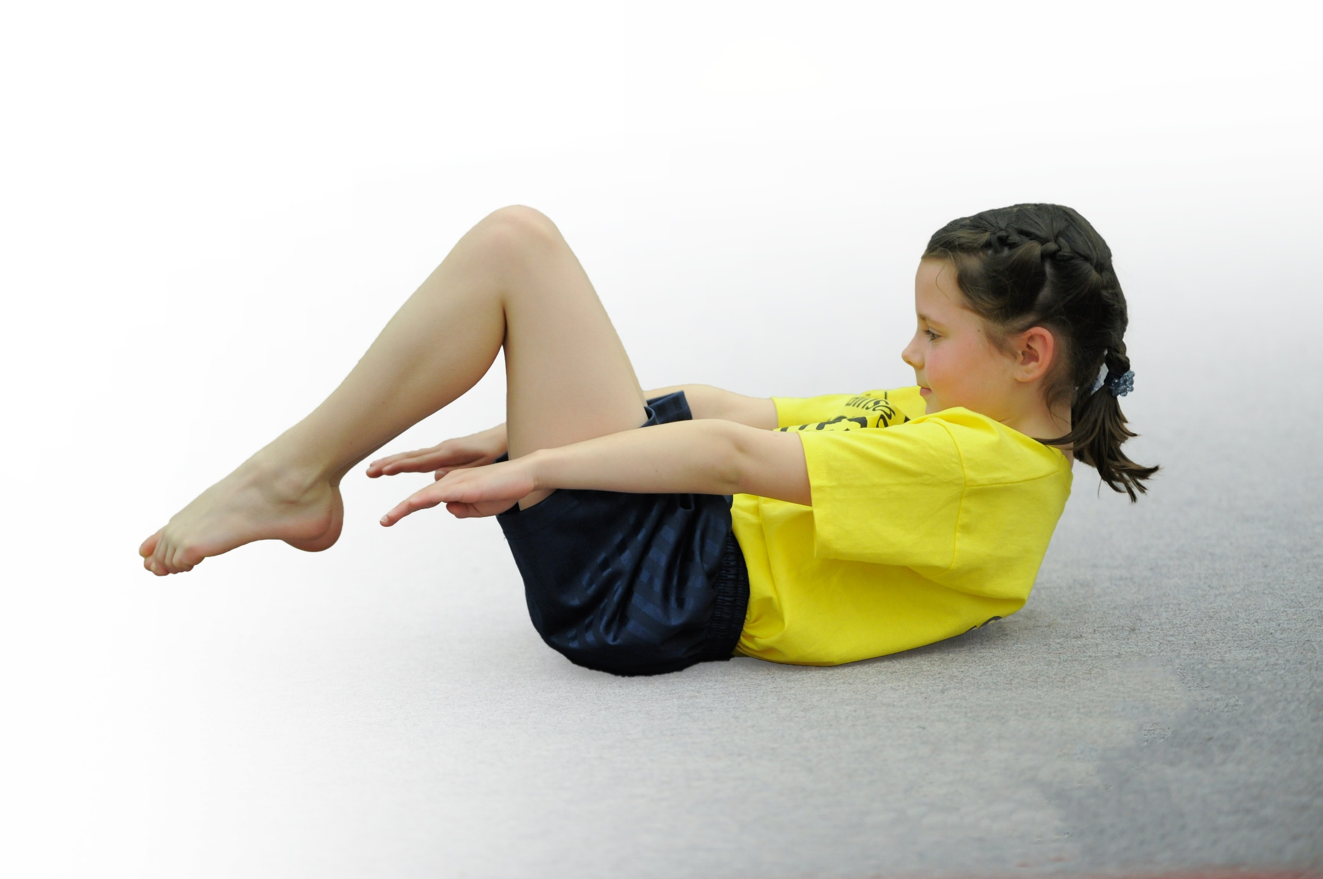
- build capacity and capability within the school to ensure that improvements made now will benefit pupils joining the school in future years

Please visit gov.uk for the revised DfE guidance including the 5 key indicators across which schools should demonstrate an improvement. This document will help you to review your provision and to report your spend. DfE encourages schools to use this template as an effective way of meeting the reporting requirements of the Primary PE and Sport Premium.

We recommend you start by reflecting on the impact of current provision and reviewing the previous spend.
Under the Ofsted Schools Inspection Framework, inspectors will assess how effectively leaders use
the Primary PE and Sport Premium and measure its impact on outcomes for pupils, and how effectively governors hold them to account
for this.

Schools are required to publish details of how they spend this funding as well as on the impact it has on pupils’ PE
and sport participation and attainment.
We recommend regularly updating the table and
publishing it on your website as evidence
of your ongoing review into how you are using the money
to secure maximum, sustainable impact. To see an example of how to complete the table please click HERE.

Support for review and reflection - considering the 5 key indicators from DfE, what development needs are a priority for your setting and your students now and why? Use the space below to reflect on previous spend, identify current need and priorities for the future.

Key achievements to date: | Areas for further improvement and baseline evidence of need:
- Embedded mile a day.  - Extended club provision including a range of different sports.  - Opportunities for parents to be involved with sports within school.  - Developing sports committee (lunch activities, regular competitive and non-competitive sports days, newsletter).  - Staff more active and therefore becoming role models.  - Participation in a range of competitions, including bowls.  - Extra swimming support provided for those not achieving 25m.  - Pupil Voice | - 60 mins of exercise per day (30 mins within school)  - Broader range of sports  - Change 4 Life club  - Outdoor learning  - Forest schools

Meeting national curriculum requirements for swimming and water safety | Please complete all of the below:
What percentage of your Year 6 pupils could swim competently, confidently and proficiently over a distance of at least 25 metres when they left your primary school at the end of last academic year? | 85%
What percentage of your Year 6 pupils could use a range of strokes effectively [for example, front crawl, backstroke and breaststroke] when they left your primary school at the end of last academic year? | 85%
What percentage of your Year 6 pupils could perform safe self-rescue in different water-based situations when they left your primary school at the end of last academic year? | 100%
Schools can choose to use the Primary PE and Sport Premium to provide additional provision for swimming but this must be for activity over and above the national curriculum requirements. Have you used it in this way? | Yes/No

Action Plan and Budget Tracking
Capture your intended annual spend against the 5 key indicators. Clarify the success criteria and evidence of impact that you intend to measure to evaluate for students today and for the future.

Academic Year: 2017/18 | Total fund allocated: £ | Date Updated:
Key indicator 1: The engagement of all pupils in regular physical activity – Chief Medical Officer guidelines recommend that primary school children undertake at least 30 minutes of physical activity a day in school |  |  |  | Percentage of total allocation:
 |  |  |  | %
School focus with clarity on intended impact on pupils: | Actions to achieve: | Funding allocated: | Evidence and impact: | Sustainability and suggested next steps:
Staff CPD in PE  - to ensure all PE sessions are delivered to the highest standard.  - Appropriate sessions and guidelines so all staff are more confident and have resources to provide appropriate activities.  - TA’s also trained by use of sports coaches.  Mile a day  - Continue to ensure all classes complete mile a day. Use of equipment permitted with an adult to add an extra element of fitness.  More active classrooms  - Staff training to ensure children plan in times for activity outside of PE and ‘mile a day’  - Monitor timetables/planning  Wider variety of clubs  - Clubs to include both individual activities and team sports.  - Boot camp  - Fit fun  Undertaking a range of inter school events  - Lancaster and Heysham Network  - Catholic Schools Cluster  - Carnforth Schools Cluster  Sports Committee  - ensure pupils are given a voice and help school cater for more popular choices of activity to ensure the school’s offer is attractive to more pupils.  - pupil leadership delivered in schools to allow older pupils to deliver fun sessions before/lunch/after school to other pupils. Equally finding suitable roles for all. | Observations  KD to attend high quality PE training  Encourage challenge of running in all classes.  eg. Timestables through activity  Build on parental involvement  Ensure all children take part throughout the year and sign post to other clubs.  Sports Days and National Sports Week | See previous on website
Key indicator 2: The profile of PE and sport being raised across the school as a tool for whole school improvement |  |  |  | Percentage of total allocation:
 |  |  |  | %
School focus with clarity on intended impact on pupils: | Actions to achieve: | Funding allocated: | Evidence and impact: | Sustainability and suggested next steps:
SSN Primary PE and Sport Conference  - Provided updates on current national and local guidance to ensure school plans dovetail with national policy and premium spending.  - Ideas for promoting the use of the premium and intergrating PE across the school.  Sports Committee  - Raising profile by leading games at lunch time.  - Staff acting as good role models.  - Meetings with Sports committee to improve profile of PE  Mile a Day  - Children more aware of exercise and mental health  Outdoor education  - has been used to improve general pupil teamwork and particularly resilience which had previously been highlighted as an issue across school.  - Planning of OAA activities within theme. | 30 mins exercise In a day  Maths/English starters through activity  Questionnaire  AT attend Health through PE

Key indicator 3: Increased confidence, knowledge and skills of all staff in teaching PE and sport |  |  |  | Percentage of total allocation:
 |  |  |  | %
School focus with clarity on intended  impact on pupils: | Actions to achieve: | Funding  allocated: | Evidence and impact: | Sustainability and suggested  next steps:
Reception Scheme of Work  - received a respected Lancashire Scheme of Work provided the school with a resource and increased confidence for delivery of PE in the often under-focused reception class.  Multiskills course  resources has seen the understanding and implementation of fundamental movement skills fully embedded in school staff.  Lancashire PE schemes of work  The embedding PE across the curriculum course linked into whole school policy whilst refreshing staff on the use of the Lancashire KS1 and KS2 schemes of work to maximize pupil impact.  Coaching  - Dance and Drama Rec, KS1 and 2  - Bowls LKS2  - Team games KS1  - Team Games UKS2 | Observations  Questionnaire
Key indicator 4: Broader experience of a range of sports and activities offered to all pupils |  |  |  | Percentage of total allocation:
 |  |  |  | %
School focus with clarity on intended  impact on pupils: | Actions to achieve: | Funding  allocated: | Evidence and impact: | Sustainability and suggested  next steps:
Outdoor education  - climbing has been offered to KS2 both at Salt Ayre’s new climbing wall  - caving with Borwick Hall.  A variety of inter school sports  - The SSN sports festival, and C4L festivals have seen a range of pupils involved in a variety of sports including traditional and new sports like lacrosse.  Bikeability  - was offered to KS2  - balance bike work for KS1.  We have had X number of sports in school and attended X sports off site. EG  We have had X number of sports in school and attended X sports off site. EG | Ensure all children involved
Key indicator 5: Increased participation in competitive sport |  |  |  | Percentage of total allocation:
 |  |  |  | %
School focus with clarity on intended  impact on pupils: | Actions to achieve: | Funding  allocated: | Evidence and impact: | Sustainability and suggested  next steps:
So far:
- Carnforth Football Cluster
- Bowls
- Multiskills
- Swimming Gala
- Cross Country
- Athletics

By the end of the year the aim is to have 100% of KS2 having represented the school in a competition.

