

Schools must use the funding to make additional and sustainable improvements to the quality of PE and sport they offer. This means that you should use the Primary PE and Sport Premium to:

- develop or add to the PE and sport activities that your school already offers
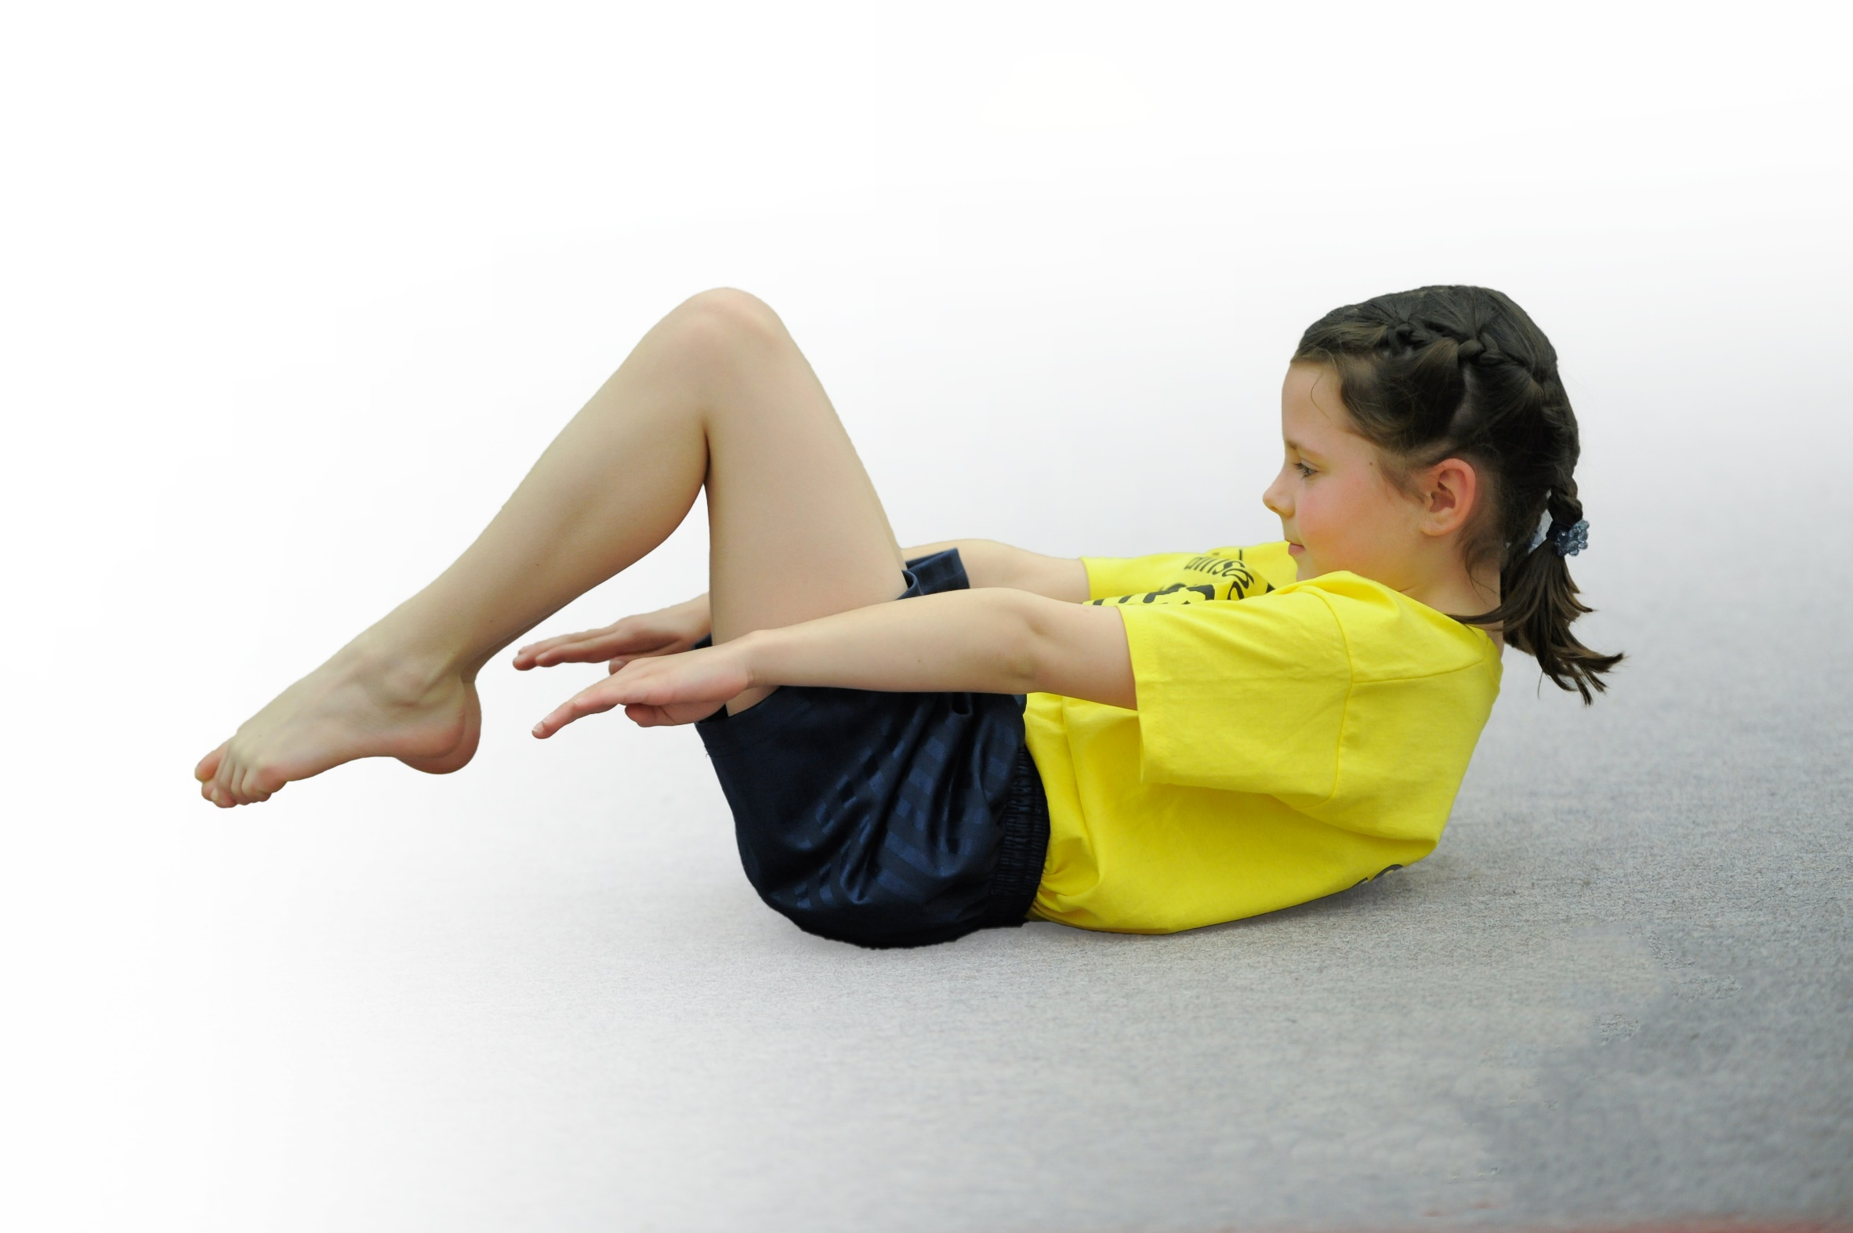
- build capacity and capability within the school to ensure that improvements made now will benefit pupils joining the school in future years

Please visit gov.uk for the revised DfE guidance including the 5 key indicators across which schools should demonstrate an improvement. This document will help you to review your provision and to report your spend. DfE encourages schools to use this template as an effective way of meeting the reporting requirements of the Primary PE and Sport Premium.

We recommend you start by reflecting on the impact of current provision and reviewing the previous spend.
Under the Ofsted Schools Inspection Framework, inspectors will assess how effectively leaders use
the Primary PE and Sport Premium and measure its impact on outcomes for pupils, and how effectively governors hold them to account
for this.

Schools are required to publish details of how they spend this funding as well as on the impact it has on pupils’ PE
and sport participation and attainment.
We recommend regularly updating the table and
publishing it on your website as evidence
of your ongoing review into how you are using the money
to secure maximum, sustainable impact. To see an example of how to complete the table please click HERE.

Support for review and reflection - considering the 5 key indicators from DfE, what development needs are a priority for your setting and your students now and why? Use the space below to reflect on previous spend, identify current need and priorities for the future.

Key achievements to date: | Areas for further improvement and baseline evidence of need:
- Embedded mile a day.  - Extended club provision including a range of different sports.  - Opportunities for parents to be involved with sports within school.  - Developing sports committee (lunch activities, regular competitive and non-competitive sports days, newsletter).  - Staff more active and therefore becoming role models.  - Participation in a range of competitions, including bowls.  - Pupil Voice  - Outdoor learning improved throughout school.  - Greater level of focus within school (Sports Apprentice)  - Healthy Heads sessions in Class 3 and 4. | - Change 4 Life club  - Greater focus on more active lessons throughout all classes.  - Forest schools  - Healthy Heads to be continued throughout school

Meeting national curriculum requirements for swimming and water safety | Please complete all of the below:
What percentage of your Year 6 pupils could swim competently, confidently and proficiently over a distance of at least 25 metres when they left your primary school at the end of last academic year? | 85%
What percentage of your Year 6 pupils could use a range of strokes effectively [for example, front crawl, backstroke and breaststroke] when they left your primary school at the end of last academic year? | 85%
What percentage of your Year 6 pupils could perform safe self-rescue in different water-based situations when they left your primary school at the end of last academic year? | 100%
Schools can choose to use the Primary PE and Sport Premium to provide additional provision for swimming but this must be for activity over and above the national curriculum requirements. Have you used it in this way? | Yes/No

Action Plan and Budget Tracking
Capture your intended annual spend against the 5 key indicators. Clarify the success criteria and evidence of impact that you intend to measure to evaluate for students today and for the future.

Academic Year: 2018/19 | Total fund allocated: £16,774 | Date Updated: 9/3/20
Key indicator 1: The engagement of all pupils in regular physical activity – Chief Medical Officer guidelines recommend that primary school children undertake at least 30 minutes of physical activity a day in school |  |  |  | Percentage of total allocation:
 |  |  |  | %
School focus with clarity on intended impact on pupils: | Actions to achieve: | Funding allocated: | Evidence and impact: | Sustainability and suggested next steps:
Staff CPD in PE  - To continue to ensure all PE sessions are delivered to the highest standard, so that children achieve the key skills in PE.  - Staff to use courses they have been on to provide high quality PE ensuring sufficient physical activity.  - TA’s and Welfare trained in delivering simple games to encourage children to complete more activity that is physical.  Mile a day  - Continue to ensure all classes complete mile a day. Use of equipment permitted with an adult to add an extra element of fitness.  - Possible challenges in class such collecting cubes to encourage children to participate more fully.  More active classrooms  - Continue to ensure staff training to ensure children plan in times for activity outside of PE and ‘mile a day’  - Keep log of other activities to ensure all children are given opportunities to be active within lessons.  Wider variety of clubs  - Wider variety of clubs offered to give more opportunities for fitness and give children better opportunities to participate.  Undertaking a range of inter school events  - Lancaster and Heysham Network  - Catholic Schools Cluster  - Carnforth Schools Cluster  Greater participation in activity for all children.  Sports Committee  - Encourage pupil leadership more fully so that children are encouraging others to be more active.  - Y5 leadership course  - Ensure children have a voice about activities provided.  - Sports Committee to run lunch time clubs in order to encourage others to be more active. | Observations  Encourage challenge of running or more active rather than walking in all classes.  Keep record of activities in big book with comments from children/teachers about impact.  Build on parental involvement  Offer range of clubs to variety of ages.  Employ sports apprentice to support this  Ensure all children take part throughout the year and sign post to other clubs.  Participate in Sports Days and National Sports Week  Start separate section of newsletter each month with comments section for children to give their own ideas. | Within budget of Memberships  (approx. £8000)  Money being saved for running track – this was ringfenced before the new rules brought to light in 2018.  £8000  Free | PE sessions delivered are of a high quality and staff ensure they are as active as possible with little time being sat listening to instructions.  Welfare have had training delivered by Steven Jamieson. W. Kendall( sports apprentice) has also attended this training – children have become more active at lunch time with new equipment having been purchased.  All classes complete mile a day or an activity in the hall. (This is weather dependent).  More active classrooms – still working on this.  Whole families weren’t as engaged as we hoped, but we are looking at different ways to achieve this. Maybe walking in the evening?  Wider variety of clubs is being met – sports apprentice runs at least two clubs each week. (3 were offered, but only 1 child signed up for hockey club)  Most KS2 children have already participated in school sports this.  Sports Committee need to be reminded about running their lunch time clubs. | The new PE app ensures teachers are aware of children’s start and end points and use this to assess children, leading a written assessment at the end of each block of work. Tracking is beginning to show a rise in attainment.
Key indicator 2: The profile of PE and sport being raised across the school as a tool for whole school improvement |  |  |  | Percentage of total allocation:
 |  |  |  | %
School focus with clarity on intended impact on pupils: | Actions to achieve: | Funding allocated: | Evidence and impact: | Sustainability and suggested next steps:
SSN Primary PE and Sport Conference  - Provided updates on current national and local guidance to ensure school plans dovetail with national policy and premium spending.  - Ideas from other schools about implementing PE, Physical activity and Health and fitness across schools.  Sports Committee  - Raising profile by leading games at lunch time.  - Staff acting as good role models.  - Meetings with Sports committee to improve profile of PE  - Articles in newsletter about PE  Welfare training  - Welfare staff more aware of importance of PE  Mile a Day  - Children more aware of exercise and mental health  Outdoor education  - Each class to be involved with OAA activities to enhance children’s knowledge of what PE is.  - Continued planning of OAA activities within theme. | Attend conference  Employ sports apprentice to raise profile within PE lessons as well as through sporting events, etc  More regular sports committee meetings  Sports apprentice  Training with Steven Jamieson  Book Borwick Hall Class 3  Book Borwick Hall Class 2  Class 4 – Condover Hall  More OAA activites linked to school themes. | Included in sports network  See costs above  Free  Included in sports network  Some included in sports network  Borwick Hall paid for by parents. | Mr Kendall is able to support learning in PE therefore giving PE a higher status than in previous years.  PE is taught consistently throughout school with all teachers understanding it’s importance.  Children are aware of how important PE and exercise is for their health and mental wellbeing.

Key indicator 3: Increased confidence, knowledge and skills of all staff in teaching PE and sport |  |  |  | Percentage of total allocation:
 |  |  |  | %
School focus with clarity on intended  impact on pupils: | Actions to achieve: | Funding  allocated: | Evidence and impact: | Sustainability and suggested  next steps:
Lancashire PE schemes of work  - A respected Lancashire Scheme of Work provided the school with a resource and increased confidence for staff members.  - Fundamental movement skills booklet given to us by Lancashire.  Coaching  - Dance and Drama Rec, KS1 and KS2  - Netball and team games – KS2  - Team games and multi sports R, KS1 LKS2.  - MFC – fundamental movements | - Ensure all classes have access to Lancashire Scheme of work to support their planning.  - Ensure use of Key Learning Documents and National Curriculum to plan from.  - Teaching staff to observe to improve their skills and confidence in teaching. | £1000  +  Some included in the sports cluster | The new PE app ensures teachers are aware of children’s start and end points and use this to assess children, leading a written assessment at the end of each block of work. Tracking is beginning to show a rise in attainment.  KD HT NP WK have all attended training this year.  KD also led staff meeting about outdoor learning.
Key indicator 4: Broader experience of a range of sports and activities offered to all pupils |  |  |  | Percentage of total allocation:
 |  |  |  | %
School focus with clarity on intended  impact on pupils: | Actions to achieve: | Funding  allocated: | Evidence and impact: | Sustainability and suggested  next steps:
Outdoor education  - Class 3 overnight stay at Borwick Hall.  - X Height session  A variety of inter school sports  - The SSN sports festival, and C4L festivals have seen a range of pupils involved in a variety of sports including traditional and new sports like lacrosse.  Bikeability  - was offered to KS2  - balance bike work for KS1 and Reception. | Ensure all children involved in OAA activity throughout the year.  Book to go and arrange teams.  Organise with Go Velo. |  | All children involved in Christmas orienteering. Completed dance sessions in hall, opportunities to take part in wide range of after school clubs – golf, tag rugby, hockey, circus skills, netball, football.
Key indicator 5: Increased participation in competitive sport |  |  |  | Percentage of total allocation:
 |  |  |  | %
School focus with clarity on intended  impact on pupils: | Actions to achieve: | Funding  allocated: | Evidence and impact: | Sustainability and suggested  next steps:
So far:  - Bowls  - Multiskills  - Athletics  - Football  - Netball  - Change4Life  By the end of the year the aim is to have 100% of KS2 having represented the school in a competition.  Lunch time  Sports committee running competitive sports at lunch times.  Intra School Sports  Children to plan 3 competitive sports event throughout the year for the whole school. Arranged by sports committee.  County Level  Compete in events to ensure children have chance to compete in Blackpool | Ensure all KS2 participate in competitive sport.  Continue to keep this up and running  Meet with committee to organise events. |  | Most of children in KS2 have competed and represented the school so far this year. Mainly Y3 left to compete – the plan is to take them to the festival at Salt Ayre along with as many other KS2 as possible.  Took two teams to netball competition.

