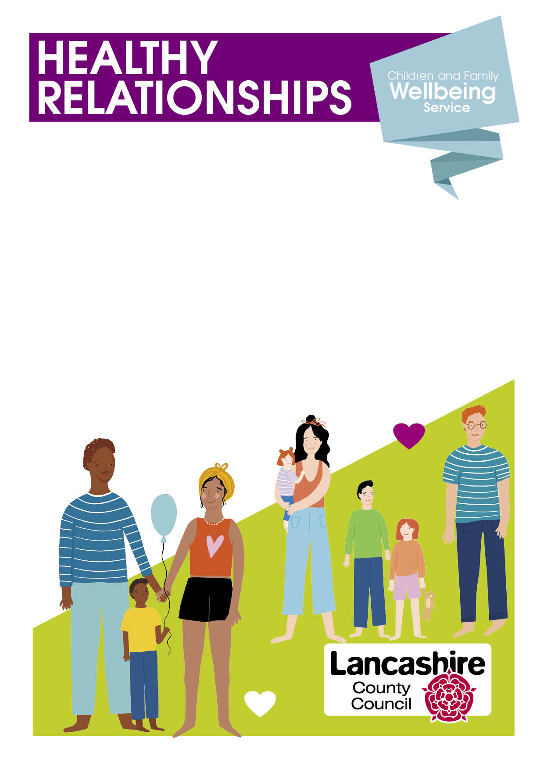
- Arguing about things like how to parent, money or
household tasks?
- Sulking, silent treatment or walking away?
- Are you able to say sorry after an argument and move on?
- Are you using hurtful words, texts or social media against each other?
- Are you anxious or worried this is getting in the way of daily life?
- Are you worried about splitting up or have split up and struggling to agree?

Our Healthy Relationships Course can help. Learning about the stages of relationships, understanding each other and how to argue better.

Remember that when you stay calm, your child feels the benefit.

If you would like a place on our course starting Tuesday January 9th 2024 -9:30-11:30 ring Lancaster Family Hub 01524 581280

