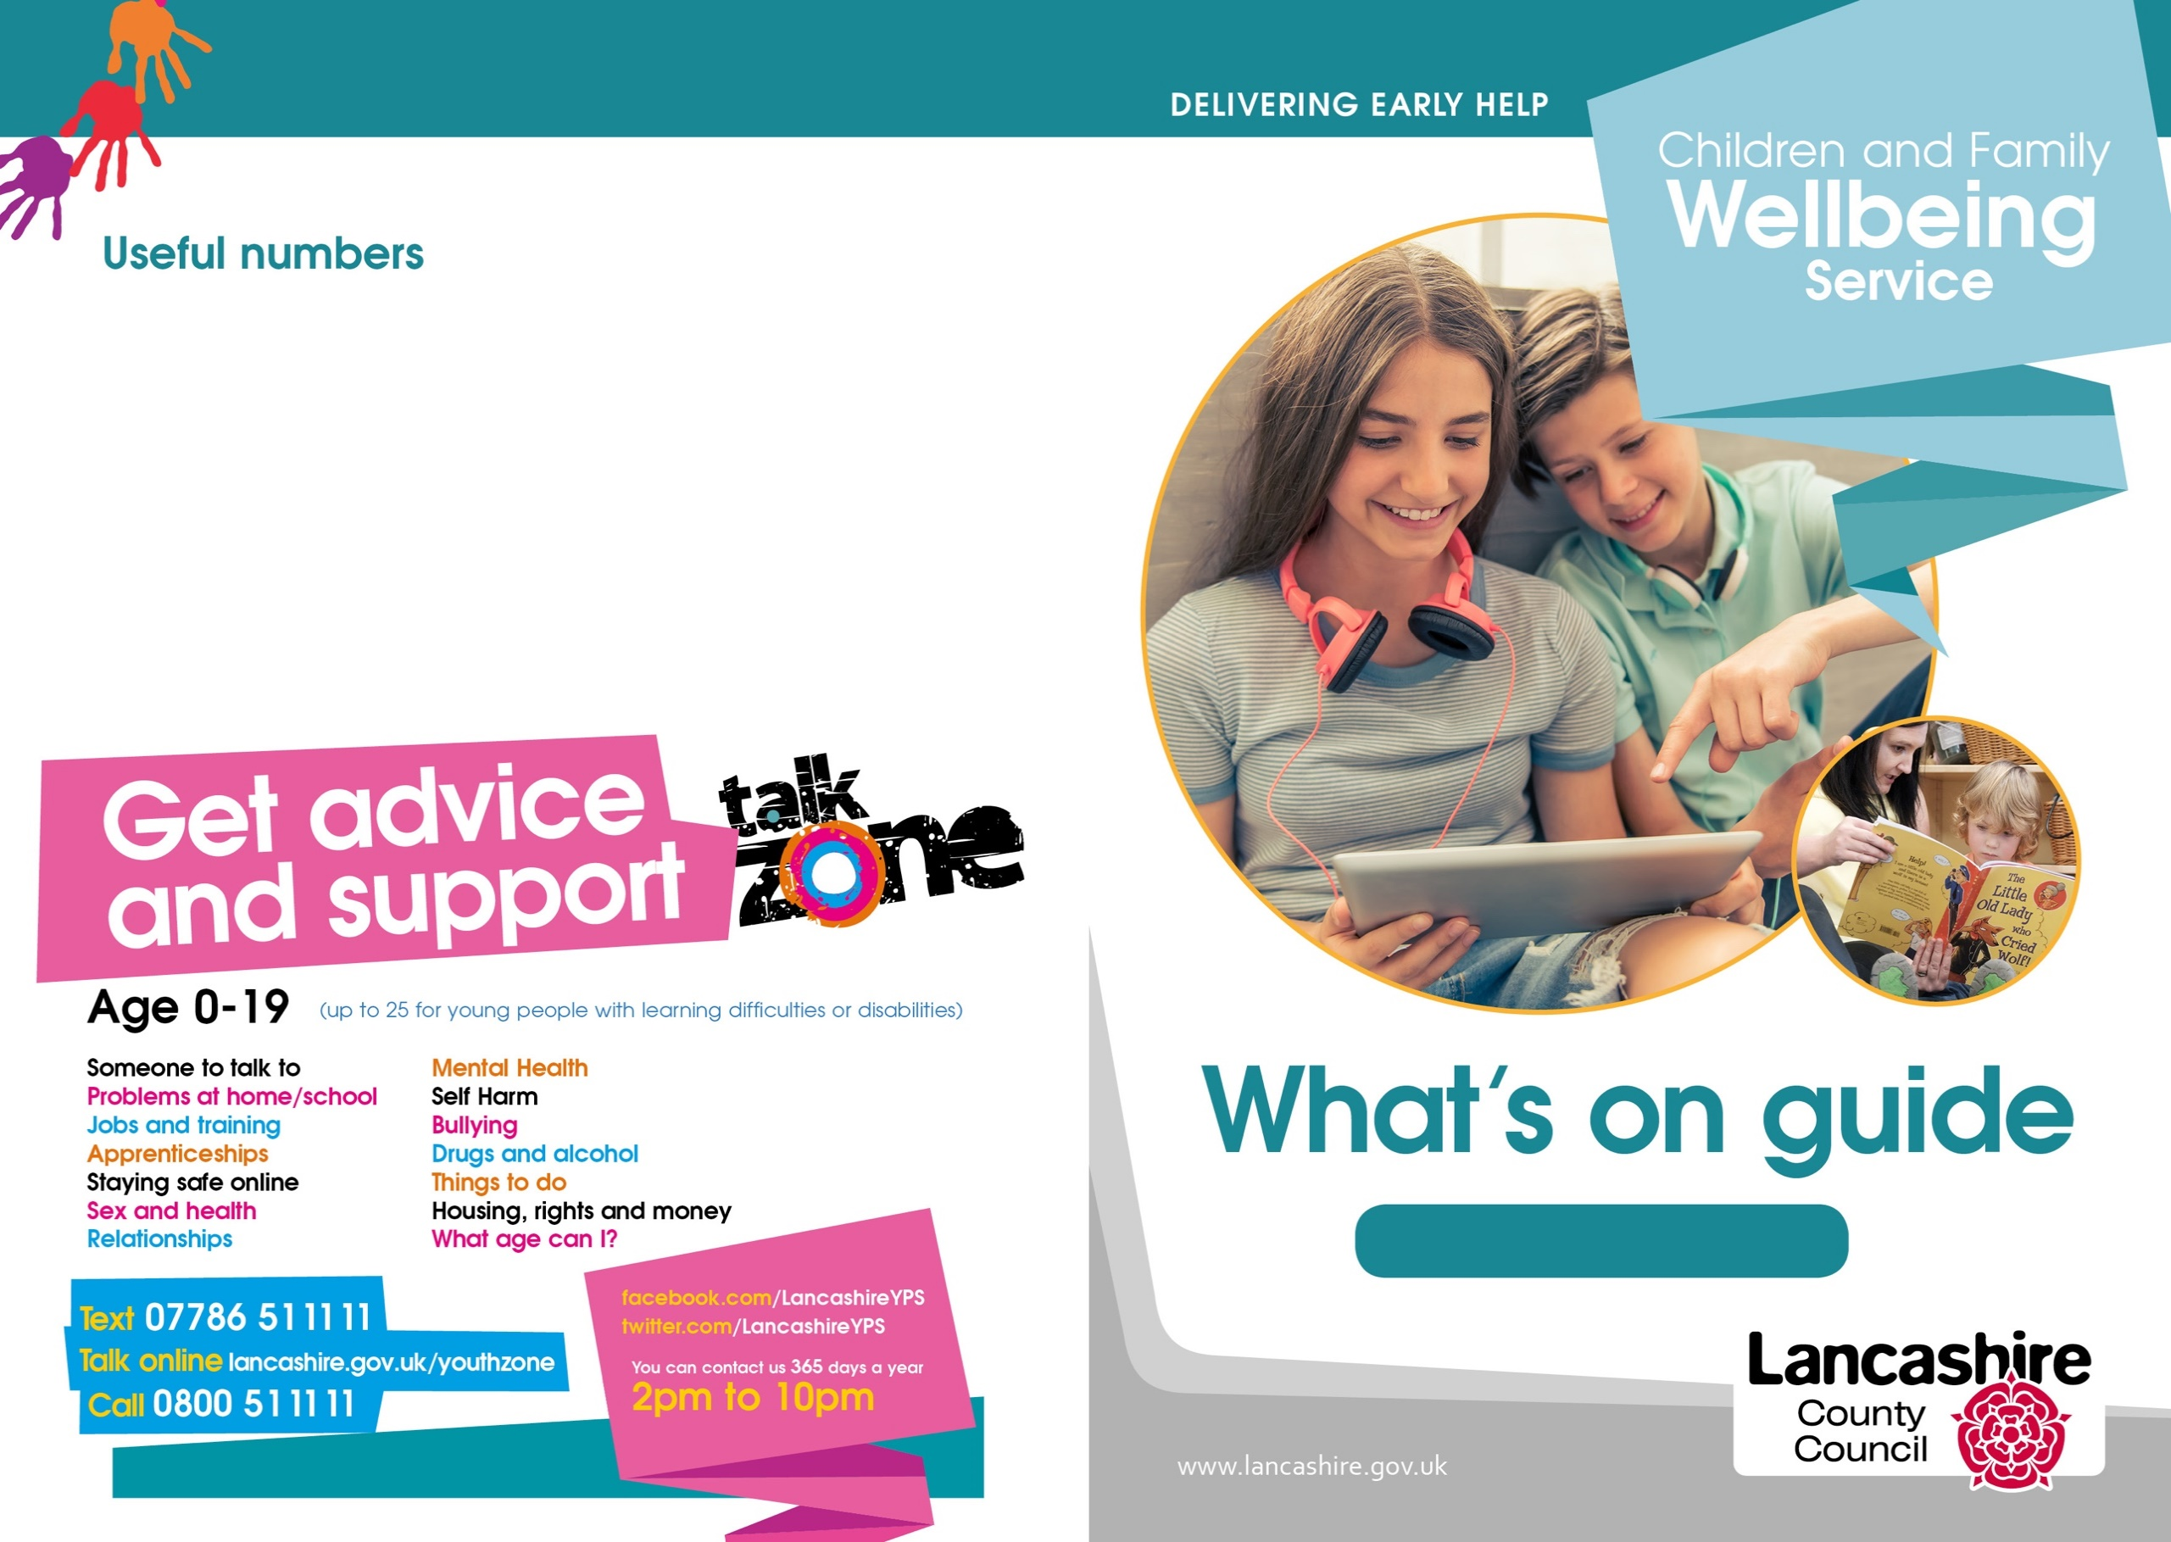
March – April 2024
To contact our Neighbourhood Centres:
01524 581280

To make a self-referral for support via the Children's Services Support Hub:
03001236720

Lancaster District
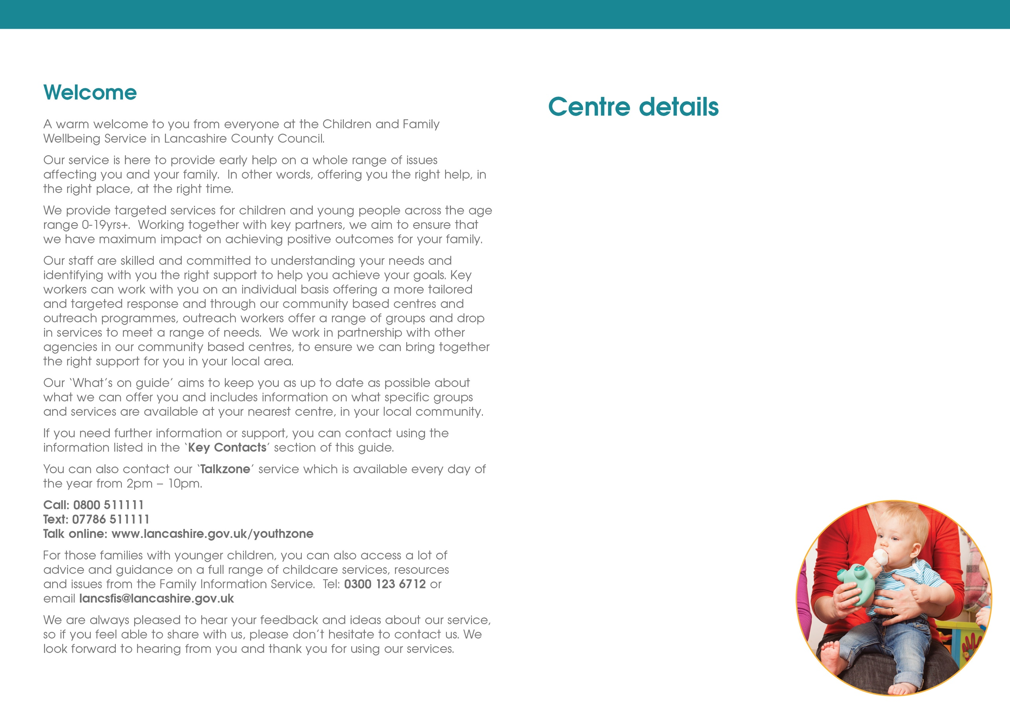
Healthy Start vitamins

If you have a Healthy Start Card, you can get your vitamins drops/tablets from us at the following centres - Lune Park, Westgate and Poulton.

Centres are opened 9am – 5pm Monday to Friday to obtain drops/tablets.



Scan the QR Code to access our Facebook page.

Lune Park Hub
Ryelands Park
Owen Road
Lancaster
LA1 2LN

Poulton Neighbourhood Centre
The Old Fire Station
Clark Street
Morecambe
LA4 5HT

Westgate Neighbourhood Centre
Langridge Way
Morecambe
LA4 4XF

Carnforth Neighbourhood Centre
Kellet Road
Carnforth
LA5 9LS

Neighbourhood Centres Telephone Contact details:
01524 581280

Lancaster and Morecambe
Family Zone

Online details
Family Safeguarding is the Children's Social Care team working in partnership with all Children's Services – please follow on
@LancsFamilies

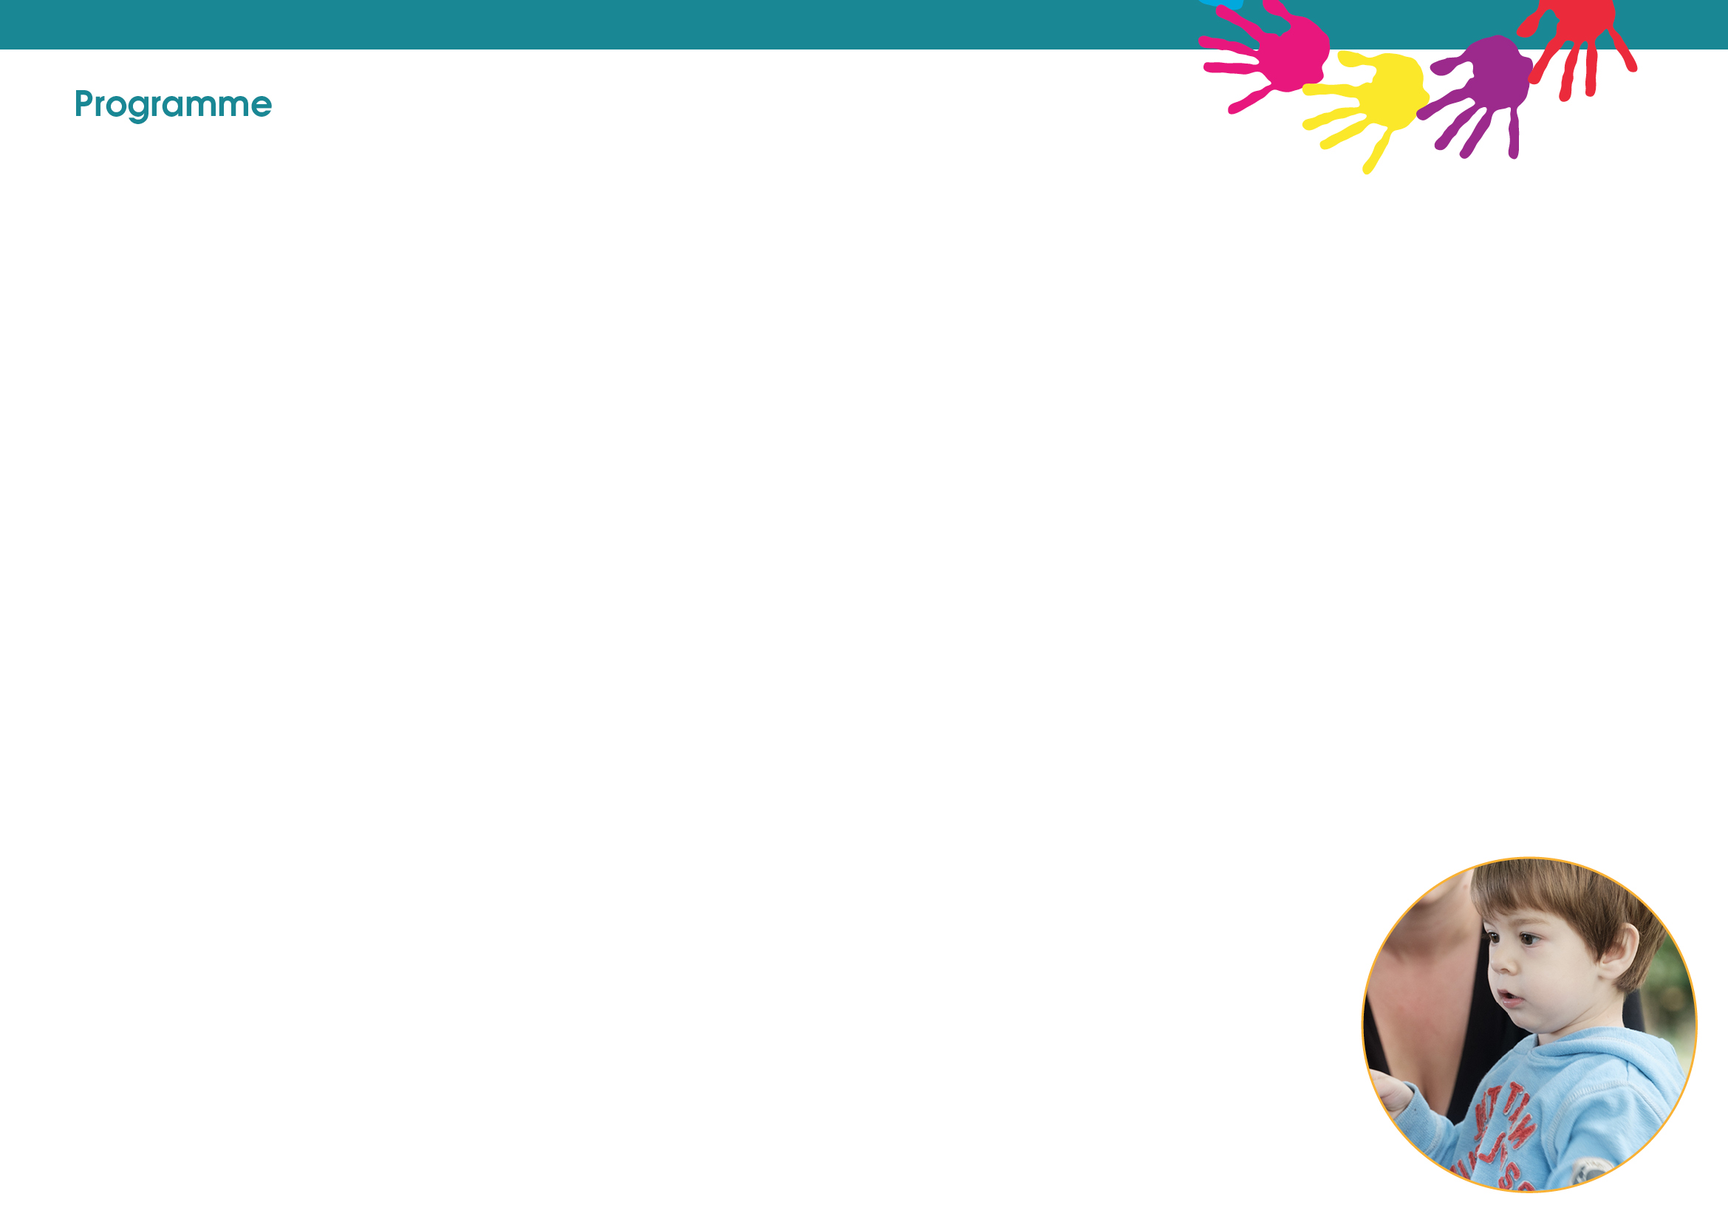
All groups are for 0 – Preschool age, apart from those which have age range stated next to them.

(B) Bookable Session.
Please call 01524 581280 for more information.

Monday

Lune Park

Baby & You (0 – pre walkers)
10am – 11am

Westgate

Special Guardianship Stay & Play
9.30am – 11am (1st Monday of the month)

Poulton

Development Matters
9.30am – 11am

Infant Massage (B)
1pm -2pm

Carnforth

FAB (Breastfeeding Support Group)
9.30am – 11am

Infant Massage (B)
10am – 11am

Development Matters
1pm – 2.30pm

Inside Out (8-11 years)
3.30pm – 4.45pm

Morecambe Library

Move & Groove (8-11years)
3.30pm – 4.45pm

Need advice/support? Citizen Advice and Smoking Cessation in pregnancy hold clinics at our centres.

To book on, please contact them on the following numbers:

Citizen Advice: 01524 581280
Smoking Cessation: 07811072610
Are you in an abusive relationship or have you been affected by domestic abuse?

We offer a friendly, group support programme online and face to face in Lancaster & Morecambe to help you move on and build a healthier, safer, more confident life. We also offer support for children who have been affected by domestic abuse.

Contact 01524 581280 for more information.

The Community Midwives Team and HRCG (Health Visitors) hold clinics across all our centres Monday to Friday.

To book into these please contact them on the following numbers:

Midwives: 01524 583367
Health Visitors: 03002470040

Friday

Lune Park

Mini Move & Groove
9.30am – 11am

Westgate

Development Matters
9.30am – 11am

Poulton
FAB (Breastfeeding Support Group)
10.30am – 12.30pm

Thursday

Lune Park
Triple P Group (B)
9.30-11.30

Inside Out (8-11 years)
3.30pm – 4.30pm

Bump, Birth & Beyond (B)
5.30pm – 7.30pm

Westgate

Chat, Play & Read
9.30am – 11am

Infant Massage (B)
1pm – 2pm

Tuesday

Lune Park

Healthy Relationships (B)
(Starts 9th Jan 2024)
9.30am – 11.30am

Infant Massage (B)
10am – 11am

Infant Massage (B)
11am-12pm

Chat, Play & Read
1pm – 2.30pm

Westgate

Baby & You
9.30am – 10.30am

Deaf Baby Group
1 – 2.30pm

Big Cook, Little Cook (B)
3.30pm – 4.45pm

Morecambe Library

Young Parents to Be
1pm – 3pm

Inside Out (8-11 years)
3.30pm – 4.45pm

Wednesday

Lune Park

Development Matters
9.30am-10.30am

Chill & Chat
10.30am – 11.30am

Colourful Footsteps
1pm– 2.30pm

Westgate

Teen Triple P (B)
1pm – 3pm

Bump, Birth & Beyond (B)
5.30pm-7.30pm

Poulton

Baby & You (0 – pre walkers)
9.30am-10.30am

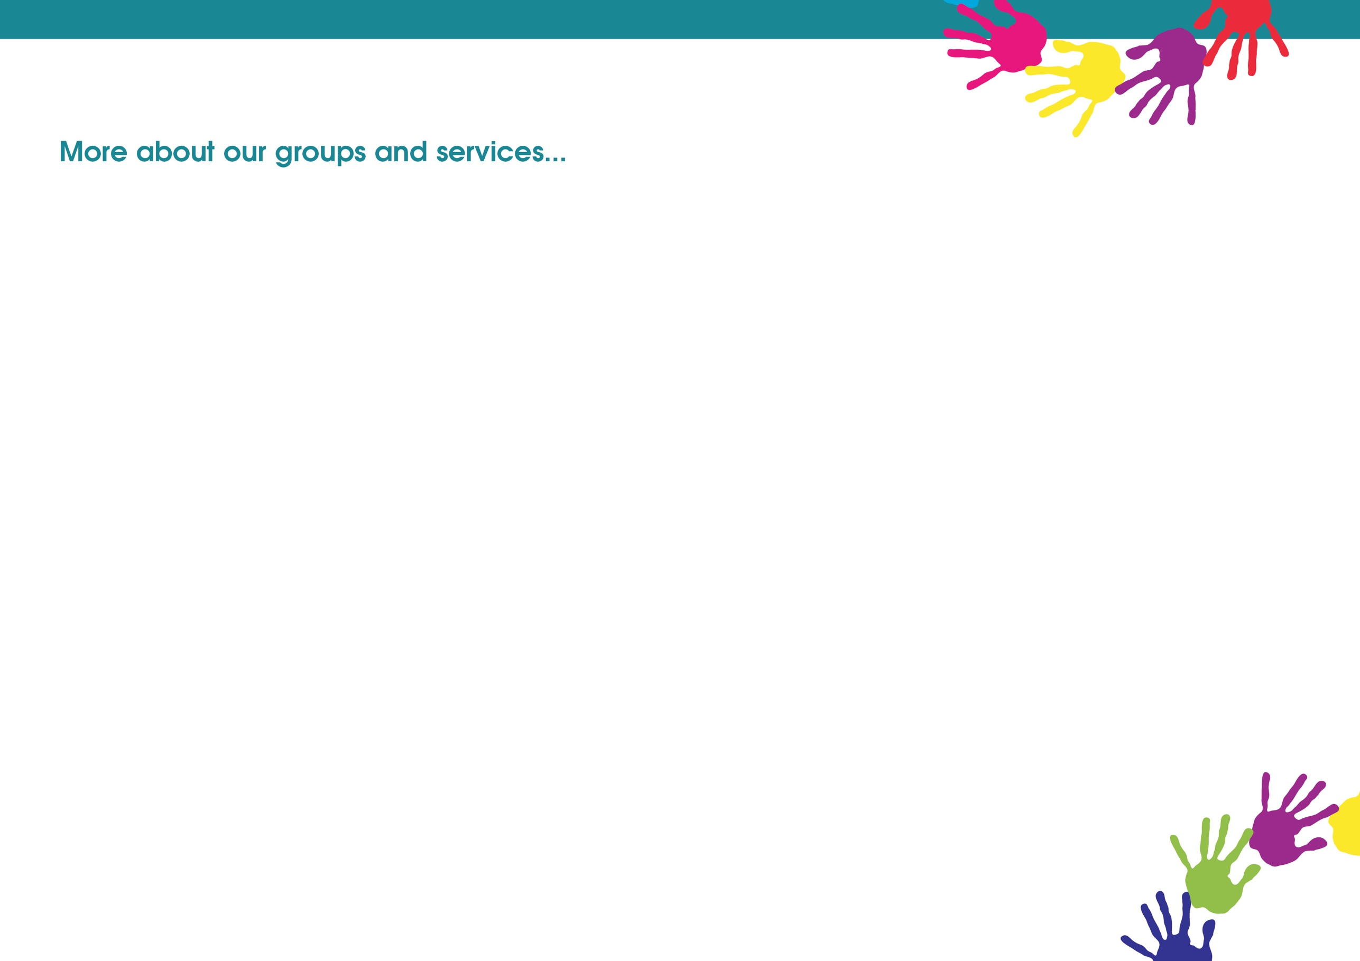
W.A.V.E.S (12 to 16yrs)
6pm – 8pm
A social group to support emotional wellbeing. An opportunity to develop your confidence and self-esteem in a safe place through arts and crafts, games, and group activities.
Taking place at White Cross on Thursday.
Contact: Nicole Cobb 07887631335 (Text/WhatsApp to book as limited places)

Open Youth Club (12 to 19yrs or up to 25 with SEND) 6.15pm – 8.30pm
This group is open to any young person in the local area. Safe space for young people to hang out with friends and opportunities to participate in a variety of activities.

Friday held at Morecambe Library
Contact: Charlie Bluglass 07977273886

PYRO (LGBTQ+) (13-17yrs)
Fun, informative sessions, exploring key topics and issues affecting young people who identify as LGBTQ+. Providing an opportunity to meet other young people, make friends, socialise, and support each other. For more information regarding date/time/venue.
Contact: Nicole Cobb 07887631335

Locality Youth Council (12 to 19yrs or up to 25 with SEND)
6.15pm – 8.30pm
A group for young people who would like to be involved in making a difference in their local community, whilst engaging in fun and enjoyable sessions. Supporting north participation, discussing local projects and issues.
Taking place at White Cross on Wednesday.
Contact: Nicole Cobb 07887631335

Prop Up Project (12 to 19yrs or up to 25 with SEND)
SAFE is a local, not for profit charity that works with young people and adults, going through mental health issues and other life challenges, incorporating both Prop Up groups for young people and Social Ease groups for adults. The organisation covers Lancaster, Morecambe and surrounding areas.

The Prop Up Project, is for young people aged 13-19 & 20-25. We run small group & individual creative activities such as drama, art and games. Alongside this, each month, we run activities to equip the group with key coping strategies and skills to maintain positive mental health and build resilience outside of our sessions.

Tuesday 5.30-7.30pm Salvation Army, Carnforth, Back Market Street. (age 13-19)
Thursday 6-8pm Rainbow Centre, Morecambe, Clarence Street (age 13-19)
Last Monday of the month 3-5pm Church of Ascension, Torrisholme (age 20-25)
Contact Claire Armer on 07717815062 or Keeley Wilkinson on 07568937988

Youth Programme
To take part in sessions contact named worker for more details.

EASY Youth Group for those with SEND (12-25yrs)
6.15pm – 8.30pm
A group for young people with special educational needs and disabilities. Activities include cooking, games and physical activities in a safe supportive environment.
Taking place at Morecambe Library on Monday.
Contact Claire Armer 07717815062

Detached Session (12 to 19yrs or up to 25 with SEND)
6.15pm – 8.30pm
Fun and interactive activities and discussions with young people out in the communities where they live, young people will lead the focus of the work.

Wednesday held in Morecambe contact Charlie Bluglass 07977273886
Thursday held in Morecambe
contact Charlie Bluglass 07977293886
Friday held in Lancaster contact
Nicole Cobb 07887631335

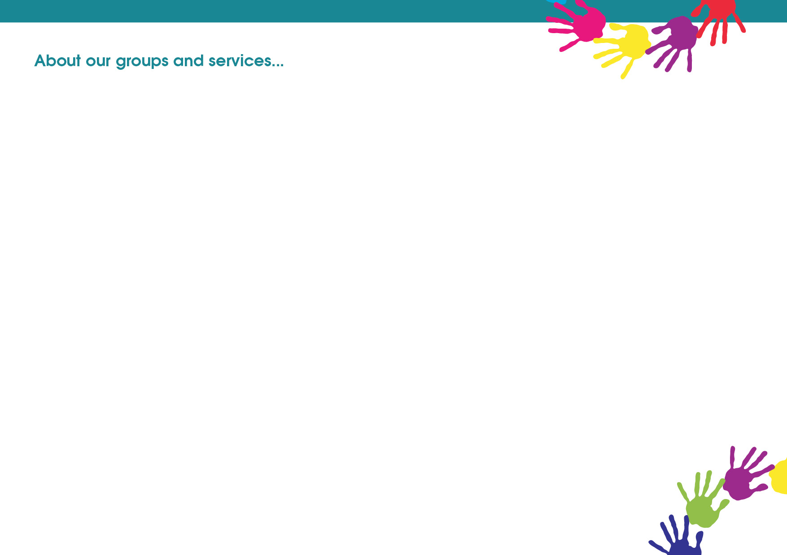

Triple P Group
Evidenced based parenting programme for parents of children aged 2-11 years old. The course is delivered across 8 sessions focused on Positive Parenting and raising confident, competent, and resilient children.

Triple P Teen
Evidenced based programme for parents with teenagers up to 16 years. The course is delivered across 8 sessions focused on raising responsible and competent teenagers.

Triple P Stepping Stones
Evidence based programme for parents who have children with a disability or other additional needs up to 12 years old. The course is delivered across 9 sessions focused on positive parenting for children with a disability and helping your child reach their potential.

Freedom Programme
Relaxed, informal group for women who have experienced domestic abuse, from a partner or family members and would like to be able to recognise abusive behaviours and understand what makes a healthy relationship.

Special Guardianship Order Group

These support groups are for families who have
Special Guardianship Order in place.

This will provide
opportunity to make
friends, and to develop
support networks within
a safe environment.
Freedom for Children
One to one and small group sessions for children who have suffered from domestic abuse. The programme offers activities that are child led, age appropriate and sensitively delivered to help children work through their fears, anxieties and emotions.

Moving On Up (Year 6 and 7)
The sessions will help children to explore feelings and emotions around transition to secondary school and build their self-esteem and confidence.

Parenting and Family Support

Chill and Chat
A warm and friendly space for people to connect with others within the community and receive information and advice if needed. Free hot drinks and snacks provided and toys available to keep your little ones entertained too.

Back To Me
This is a three-week course which allows you to focus on yourself, improves your wellbeing, and develop strategies to help you feel more confident to deal with life stressors.

Healthy Relationships
Whether you are together or separated, arguments between parents are a normal part of relationships. However, there is new evidence that shows they could have an impact on your child when they are frequent, intense, or unresolved. Healthy Relationships is a course of 6 weekly sessions which aims to empower you to understand conflict in your relationship and see how to resolve the issues yourselves.

Triple P Teen
Evidenced based programme for parents with teenagers up to 16 years. The course is delivered across 8 sessions focused on raising responsible and competent teenagers.

Early Childhood Services (0-5)

Parents To Be
Preparing for parenthood through sharing key messages on Safer sleep, ICON, home safety, caring for a newborn's needs and the importance of communication.

Young Parents to Be
Antenatal group for parents aged 20 and under, delivered alongside the Specialist midwife for Teenage Pregnancy.

Infant Massage – birth to crawling
A six-week programme which involves gently and rhythmically stroking your baby's body to promote bonding and interaction.

Baby and You
This group encourages positive play and interaction between you and your baby with key messages about how to care for your baby through their early stages of development.
Development Matters
Stimulating and challenging activities across all ages from 0-5yrs based on child-initiated play guided by the Early Years Foundation Stage Development Matters.

Chat, Play and Read
The sessions will provide opportunities to read and share books together, exploring the fun, rhythms and excitement of words and stories to support your child’s speech and language development.

Mini Move and Groove
A range of physical health and wellbeing activities for early years children to help guide them on their first steps to living well and boosting their physical and motor development.

The Developing Child (5-11)

Inside Out (8-11 years - Key Stage 2)
Emotional health and wellbeing targeted group. A range of strategies and creative, physical activities to encourage positive play, build self-confidence and manage anxious feelings.

Move and Groove (5-8 years and 8-11 years)
A safe, sensitive and nurturing space for children to meet and have fun together, promoting physical activity and healthy lifestyles.

Colourful Footsteps
A group for children with physical, learning, behavioural or emotional difficulties. We offer an inclusive environment, positive social interactions and learning and development opportunities.

