
OUR LADY OF LOURDES CATHOLIC PRIMARY &
NURSERY SCHOOL


School Subject Guidance for
ENGLISH (Reading & Writing)
(2021/22)
Subject Leader: Mrs Liz Kendall

TIMETABLE

All classes have 1hr and 45 minutes timetabled for the teaching of English four days a week, with 30/45 minutes specifically allocated to Reading tasks – one of which is Guided Reading and the other Everyone Reading in Class.

Children in EYFS and Key Stage One also have a daily Phonics session everyday.

CURRICULUM MAP:

The English curriculum map is in place to give an outline of the learning opportunities in English over the year. This shows Fiction, Non-Fiction and Poetry and has links to Grammar, Punctuation and Spelling.
The map is revisited annually to ensure that we look at expectations within the class structure that we have put in place for that year.
The curriculum map includes an overview and units of work linked to the planning process.

PLANNING DOCUMENTS:

All teachers must plan sequences of learning using our bespoke units of work based on the Key Learning from Lancashire.
Planning should follow the “Planning Guidance” (see Appendix 2) when looking at different genres and given to the Subject Leader so that they can be monitored and feedback given to staff as necessary.

Lessons should in most instances be structured as follows:
- Activating Prior Knowledge
- Quality First Teaching – instruction and modelling
- Success Criteria – memorisation of strategy
- Guided Practice with scaffolding
- Independent Practice
- Structured Reflection

ASSESSMENT for LEARNING
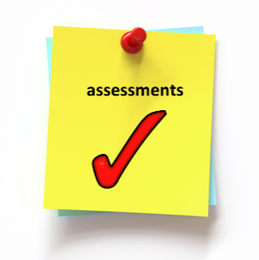
Teachers should identify what children already know at the beginning of each session. The outcome of what the children will learn should be clearly communicated, to the class during each lesson as identified on teacher’s plans.
At the end of a lesson, children should self-assess their work with the school traffic light system.

It is essential that teachers maintain a record of attainment against Key Learning using the Marking Ladders.

Assessments are carried out termly (December, April and July) and recorded on iTrack Primary. Statutory assessment in Years 1, 2 and 6 will take place in accordance with national timetables.

PHONICS:
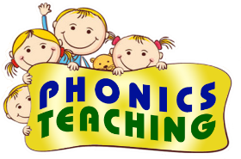
All sessions of Phonics should be PACY and sharply focused will follow:
- Revisit/Review (warm-up/recap)
- Teach
- Practice
- Apply


GUIDED READING:
Each class must complete reading comprehensions weekly.

HANDWRITING:
All classes must include sessions focused on the teaching of handwriting.

READERS:
All teachers should aim to read 1:1 with all children in their class at least once a week.
All classes include a list of Daily Readers based upon data from termly assessments.

BIG WRITE:
All classes have a longer writing session weekly, which could be cross-curricular.

◊◊◊◊◊◊◊

Written by: Mrs Liz Kendall
Implementation: September 2020
Version 3: October 2021
Review: July 2022

Appendix 1

OUR LADY OF LOURDES CATHOLIC PRIMARY & NURSERY SCHOOL
School Guidance for

Guided Reading Tasks (2021/22)

GROUP | Monday | Tuesday | Wednesday | Thursday
1 | Adult-led  Guided Reading Session | Independent  Tasks  (Spelling/  Comprehension) | Grammar & Phonics Task | Vocabulary
2 | Vocabulary | Adult-led  Guided Reading Session | Independent  Tasks  (Spelling/  Comprehension) | Grammar & Phonics Task
3 | Grammar & Phonics Task | Vocabulary | Adult-led  Guided Reading Session | Independent  Tasks  (Spelling/  Comprehension)
4 | Independent  Tasks  (Spelling/  Comprehension) | Grammar & Phonics Task | Vocabulary | Adult-led  Guided Reading Session



Appendix 2
OUR LADY OF LOURDES CATHOLIC PRIMARY SCHOOL

9
School Planning Guidance for
ENGLISH (2021/22)

When planning for English sessions consideration of the following needs to be considered:
Select:
- Key Reading skills
- Key Writing skills including Grammar, Spelling and Handwriting
- Speaking and listening opportunities/ICT links
- What is your Outcome? – e.g. new chapter/explanation/recount/description – adjust the unit length accordingly

Creating interest
- Use a film clip, image, read short section of novel/story, objects around classroom to stimulate interest.
- Speaking and listening e.g. talk partners/groups to engage in the theme
- Short writing opportunity e.g. predict, summarise, thoughts, vocabulary generation
Reading and Responding (use Key skills for reading)
- Read short section of text (from a novel/class novel)

Use speaking/listening or drama to deepen understanding and provide a reading response/short writing opportunity each day
Reading and Analysing (use Key skills for reading)
- Unpick the text structure e.g. story mountain or story map in narrative – box up a text for non-fiction
- Create a list of features for the text type e.g. how to write a letter/explanation
Gathering Content/Planning (use Key skills for writing)
- Create and explore new content to prepare for writing
- Use drama, film, image, story box, research etc.
- Rehearse the new content within the text structure frame from analysis
Planning (use Key skills for writing)
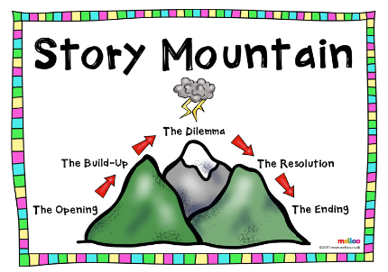
- Use a frame or scaffold/story mountain or non-fiction frame to talk, draw, make notes and clarify new content and then plan ready for writing
Writing (use Key skills for writing)
- Use the plan to demonstrate a short section of writing e.g. paragraph – shared writing – children complete their own first paragraph
- Repeat this model each day until the writing is completed
- Provide opportunities for children to share their writing with a partner/TA – response partners to celebrate and give advice and respond to the advice
Presentation – in literacy session or cross-curricular
- ‘Publish’ the final piece of writing into a book/poster/use ICT/for display – this may be used in the parent presentation at the end of the term.
Assessment
- Provide a stimulus e.g. image/short film extract/role play/object to set up an independent writing opportunity. Children to need to write at length in a specified session.
- Plan for another opportunity to write in the same genre within cross-curricular contexts or several weeks later in literacy.

